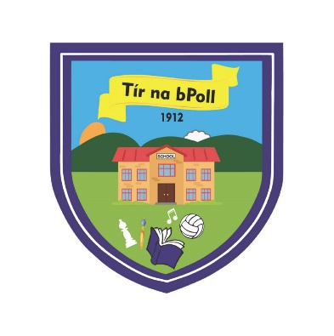
ANNUAL ADMISSION NOTICE
Tiernaboul National School
Tiernaboul, Killarney, Co. Kerry, V93 D362
Tel: 064 – 6634767
Email: tiernaboul1ns@gmail.com
Website: www.tiernaboulns.ie
Roll No: 15644F

Admission Policy and Application Form
A copy of the school’s Admission Policy and the Application Form for Admission for the 2026/27 School Year is available as follows:
On request: By emailing: tiernaboul1ns@gmail.com or writing to: Tiernaboul National School, Tiernaboul, Killarney, Co. Kerry, V93D362 or calling 064 6634767
And online from the Enrolment link on this website https://www.tiernaboulns.ie/parentscorner

PART 1 - Admissions to the 2026/27 school year
Application and Decision Dates for admission to 2026/27 School Year:
The following are the dates applicable for admission to Junior Infants:
The school will commence accepting applications for admission on: | 3rd November 2025
The school shall cease accepting applications for admission on: | 28th November 2025
The date by which applicants will be notified of the decision on their application is: | 19th December 2025
The period within which applicants must confirm acceptance of an offer of admission is: | 1 month

*Failure to accept an offer within the prescribed period above may result in the offer being withdrawn
Note: the school will consider and issue decisions on late applications in accordance with the school’s admission policy.
Number of places being made available in 2026 / 2027
The number of places being made available in junior infants is: | 14

